Computer networks lab report
Submitted By
GRANDHI PRANAY
RA2411030050039
Under the guidance of
Dr. Mallika
(Assistant Professor, School of Computing)
in partial fulfilment for the award of the degree
of
BACHELOR OF TECHNOLOGY
in
DEPARTMENT OF COMPUTER SCIENCE AND ENGINEERING WITH CYBER SECURITY
Of
FACULTY OF ENGINEERING AND TECHNOLOGY

SRM INSTITUTE OF SCIENCE AND TECHNOLOGY, TIRUCHIRAPPALLI
Academic Year: 2026–2027

1. Objective
To construct two small Local Area Networks in Cisco Packet Tracer, assign static IPv4 addresses to the hosts and prove reachability with the ping utility. The experiment also shows how the choice of cable and the presence of a switch affect the way the link behaves.
- Task 1: PC0 and PC1 joined through a switch with straight-through cables, network 192.168.1.0/24.
- Task 2: PC0 and PC1 joined by a cross-over cable, network 192.168.10.0/24, and later joined again through a 2960 switch.

2. Components Used
Component | Qty | Role in the experiment
PC-PT (PC0, PC1) | 2 | End hosts that generate and answer ping
Switch (Switch-PT, then 2960-24TT) | 1 | Learns MAC addresses and forwards frames
Copper Straight-Through cable | 2 per switch set-up | Links PCs to the switch
Copper Cross-Over cable | 1 | Direct PC-to-PC link

3. Background: What Happens During a Ping
Before PC1 can send an ICMP echo request to 192.168.1.1 it must know the MAC address of that host. It broadcasts an ARP request; the switch floods it, PC0 answers, and the switch records each sender's MAC address against the port it arrived on. From then on frames are sent only out of the correct port.
Because both addresses share the network part 192.168.1 (mask 255.255.255.0), the PCs treat each other as directly reachable and do not need a gateway. The same logic applies to 192.168.10.1 and 192.168.10.2. In Packet Tracer, an orange dot on a link means the port has not yet started forwarding, and a green triangle means it is active.

4. Task 1: PC to PC through a Switch

4.1 Procedure
Step 1 - Add the devices. In Logical view drag two PCs out of End Devices, then pick a switch from Network Devices and drop it between them.
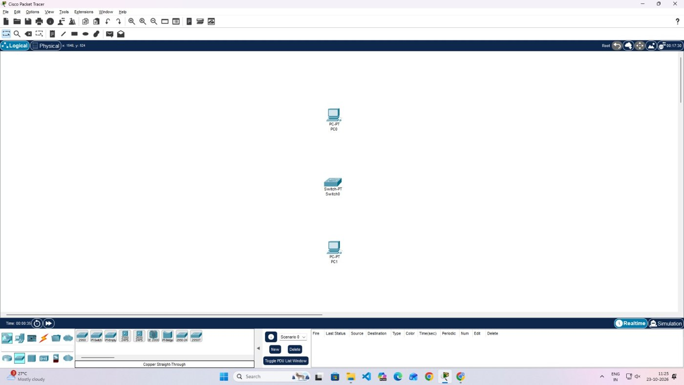
Figure 1: PC0, Switch0 and PC1 placed; nothing is cabled yet
Step 2 - Choose the cable. From Connections pick Copper Straight-Through. A PC and a switch are unlike devices, so no crossing of pairs is needed.
Step 3 - Wire PC0. Click PC0, select FastEthernet0, then click Switch0 and take any free FastEthernet port.
Step 4 - Wire PC1. Repeat for PC1. While the switch ports start up, the link ends show orange dots.
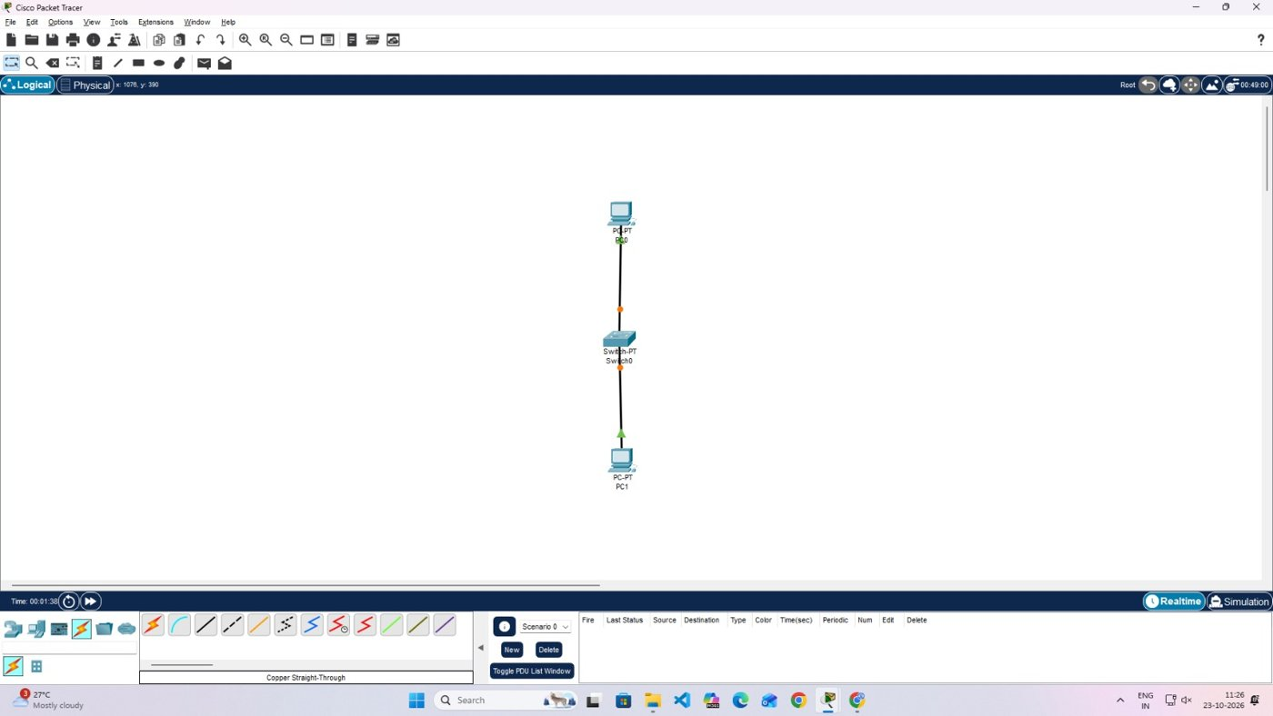
Figure 2: Both cables attached; orange dots on the switch side
Step 5 - Let the ports come up. Give it a few seconds. The dots become green triangles, so the PCs can be configured.
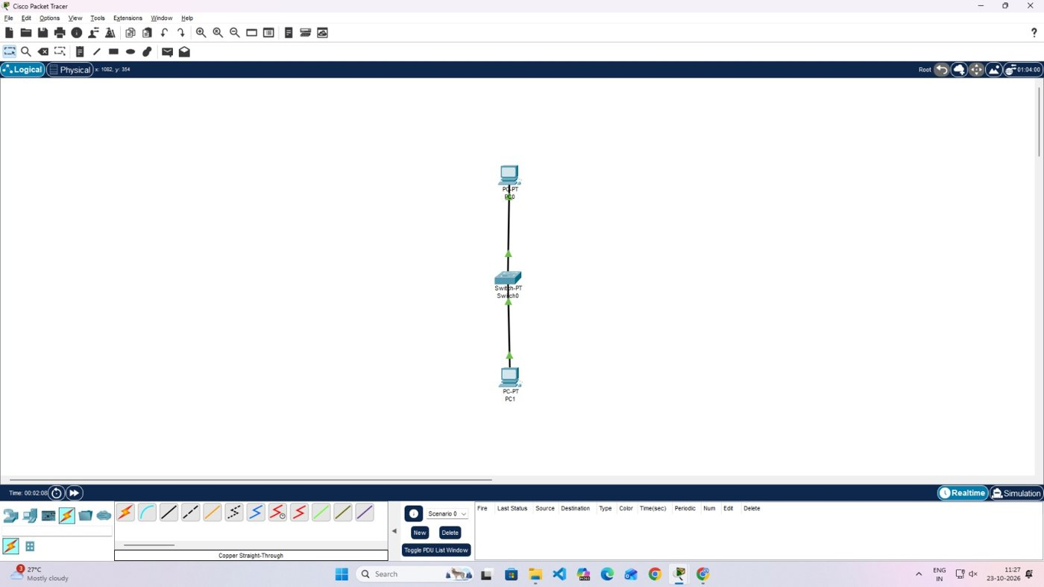
Figure 3: Both links forwarding
Step 6 - Address PC0. Open PC0 > Desktop > IP Configuration, tick Static and type 192.168.1.1 with mask 255.255.255.0. The gateway stays 0.0.0.0.
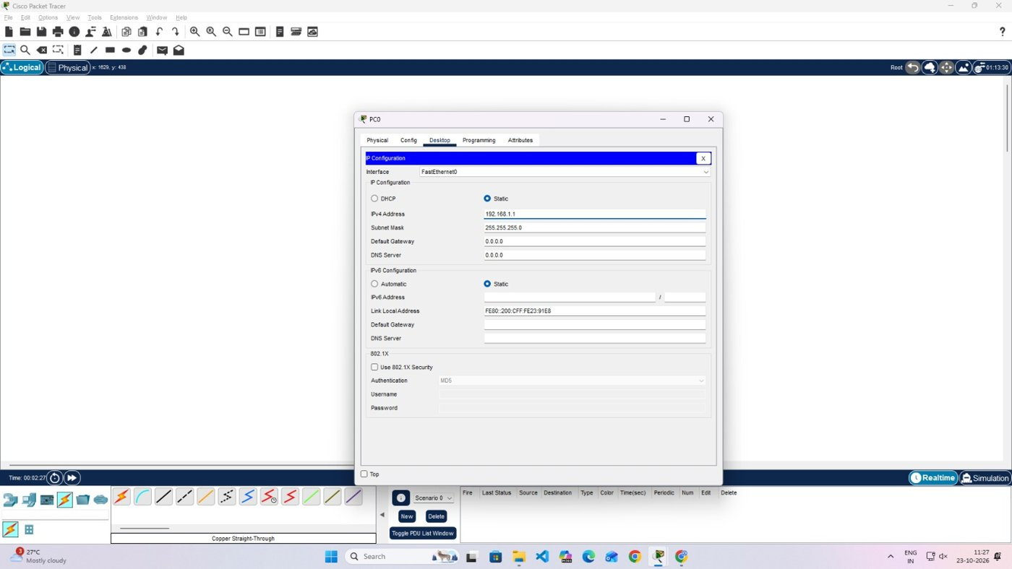
Figure 4: IP Configuration window of PC0
Step 7 - Address PC1. Do the same on PC1 with 192.168.1.2 and mask 255.255.255.0.
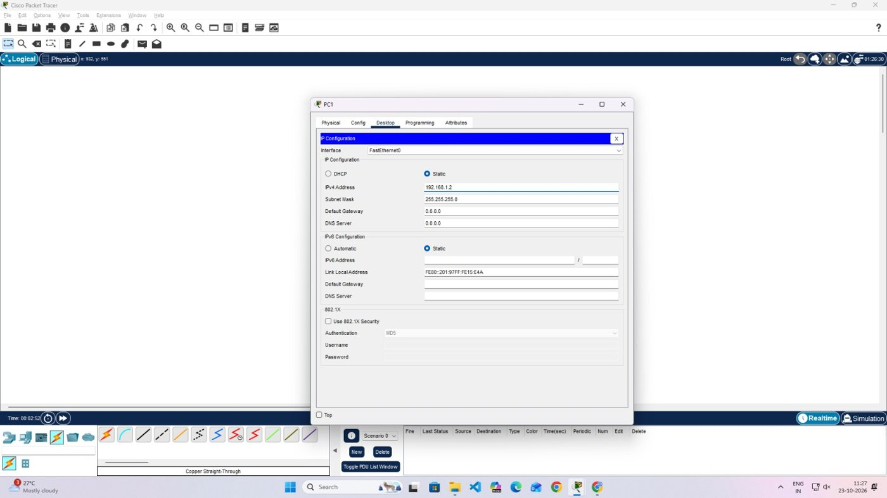
Figure 5: IP Configuration window of PC1
Step 8 - Ping from PC1. Open Command Prompt on PC1 and run ping 192.168.1.1. Every request is answered.
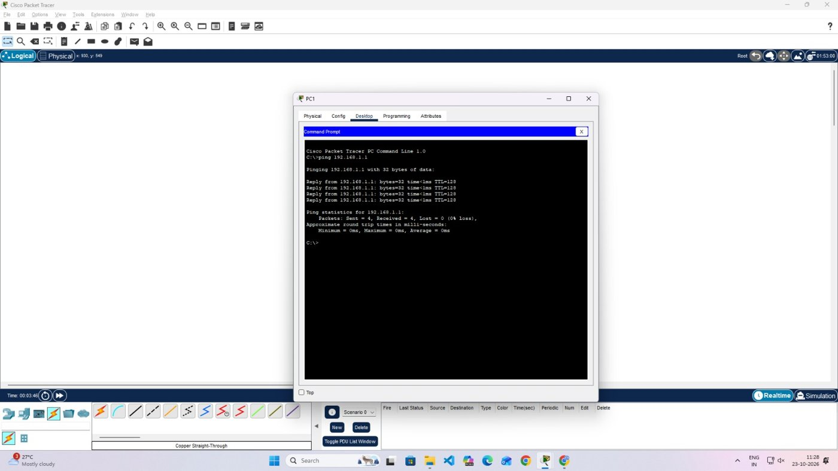
Figure 6: Ping from PC1 to PC0
Step 9 - Ping from PC0. Run ping 192.168.1.2 from PC0 to prove the path works in the other direction too.
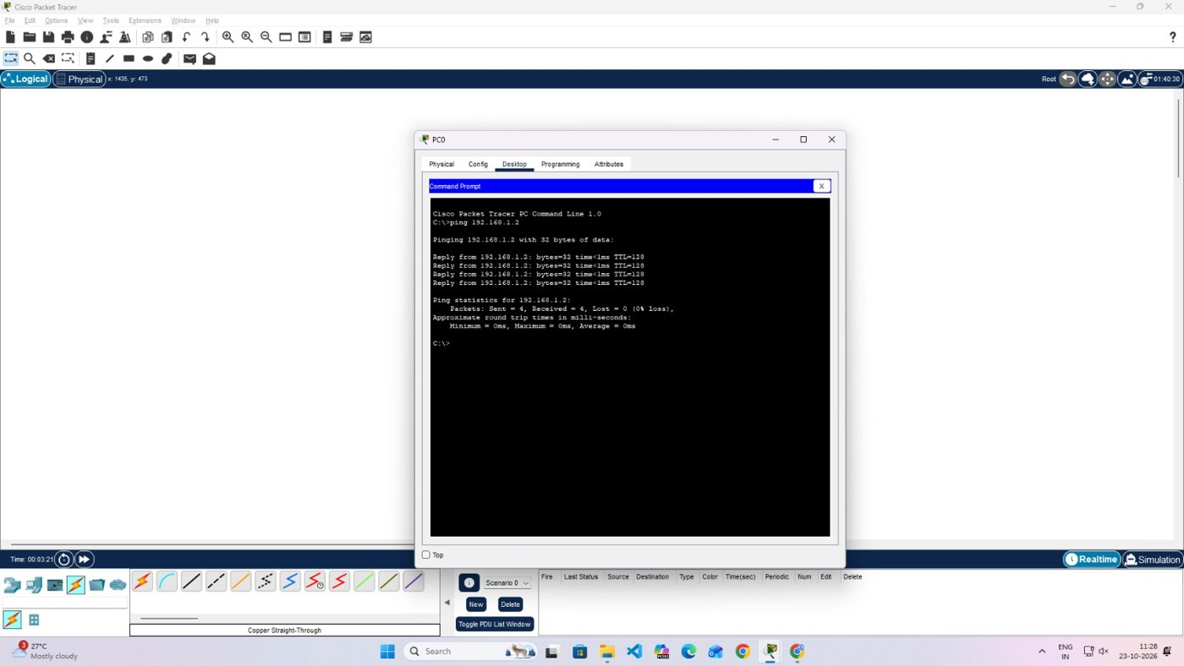
Figure 7: Ping from PC0 to PC1
Step 10 - Follow a packet. Press Simulation, add a PDU between the PCs and step through the Event List; the envelope passes through Switch0.
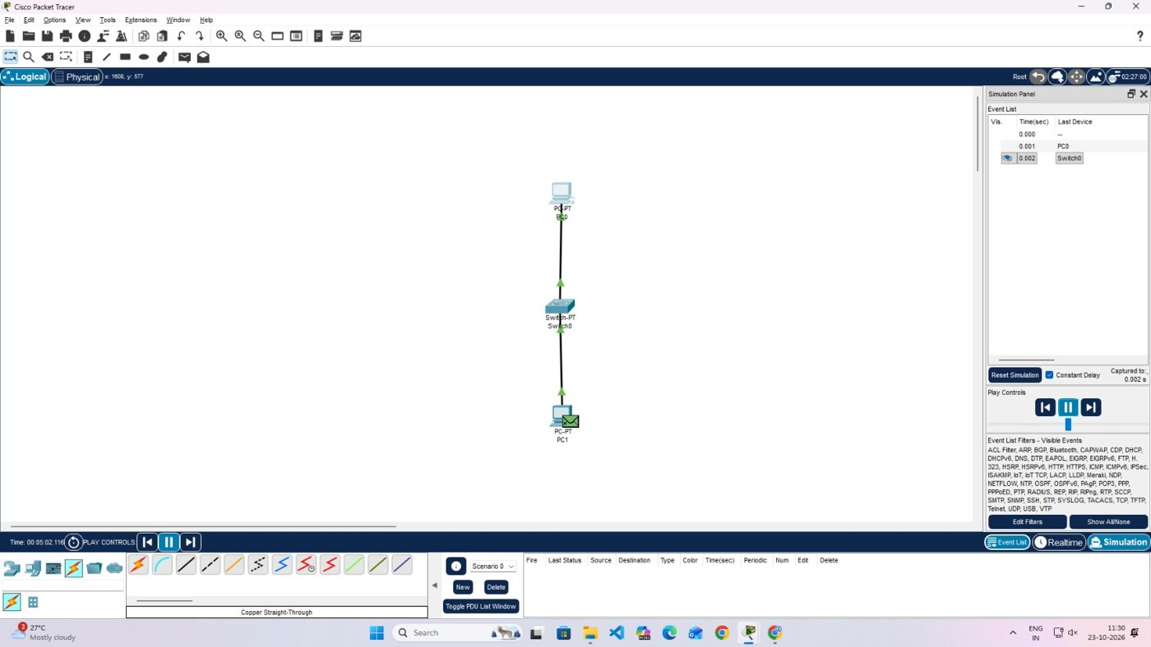
Figure 8: Packet seen at Switch0 in Simulation mode

4.2 Addressing Table
Device | Interface | IP Address | Subnet Mask | Gateway
PC0 | FastEthernet0 | 192.168.1.1 | 255.255.255.0 | 0.0.0.0
PC1 | FastEthernet0 | 192.168.1.2 | 255.255.255.0 | 0.0.0.0

4.3 Observation
Both ping tests ended with Sent = 4, Received = 4 and Lost = 0. Round-trip times were under 1 ms and the TTL of each reply was 128.

5. Task 2: Cross-Over Cable, then Switch

5.1 Procedure
Step 1 - Add two PCs. Open a clean workspace and place PC0 and PC1.
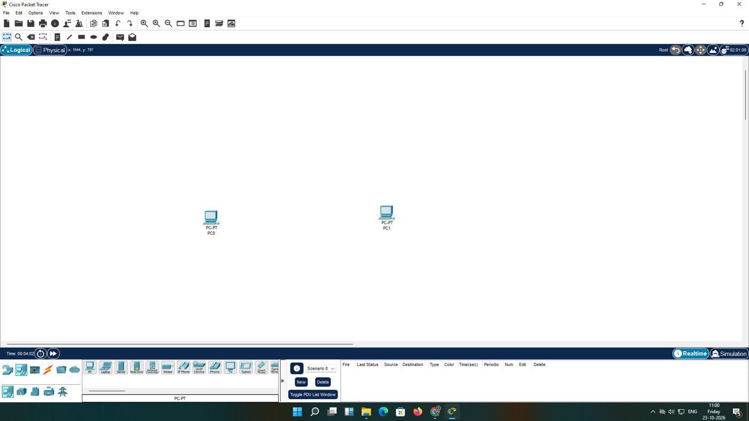
Figure 9: Two PCs on an empty workspace
Step 2 - Choose the cable. Pick Copper Cross-Over, because the two ends are like devices.
Step 3 - Pick the interface. Click PC0. The list shows RS 232, USB0, USB1 and FastEthernet0; choose FastEthernet0.
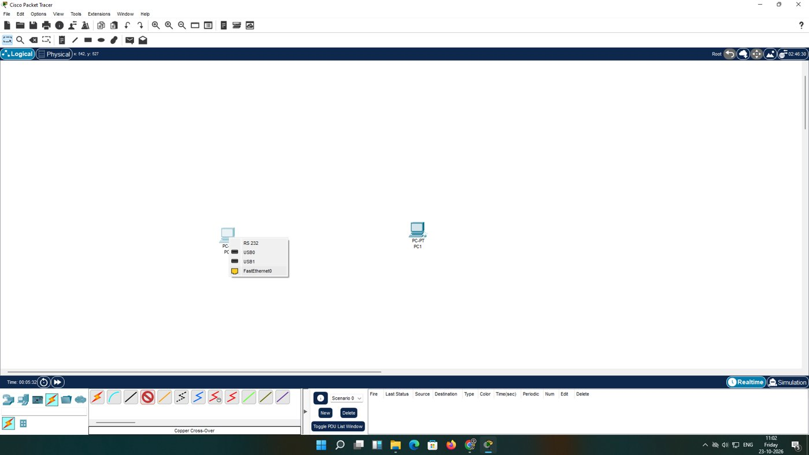
Figure 10: Interface list of PC0
Step 4 - Close the link. Click PC1 and choose FastEthernet0. A dashed cable with green triangles at both ends appears.
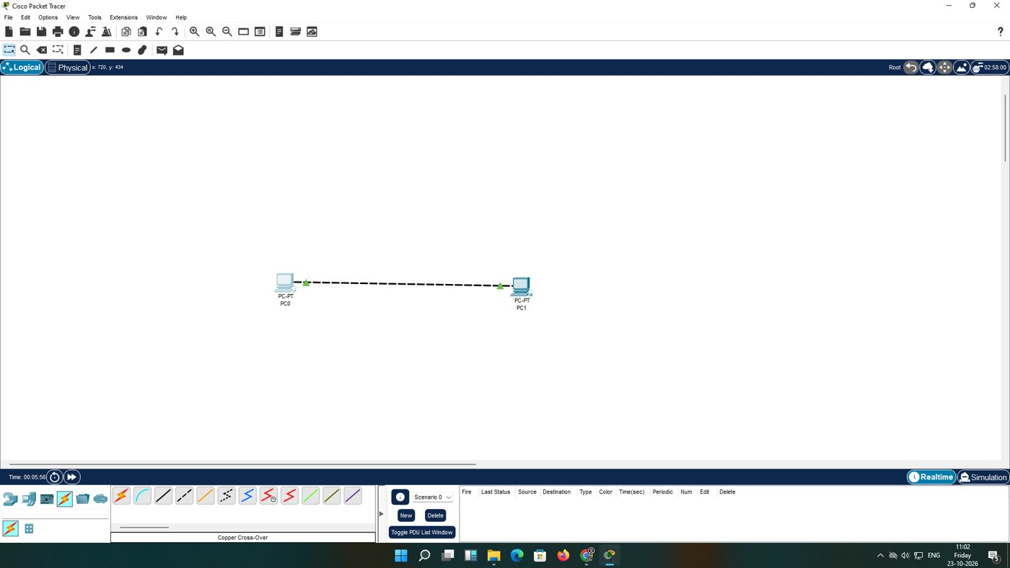
Figure 11: PC0 and PC1 linked directly
Step 5 - Address PC0. Static address 192.168.10.1, mask 255.255.255.0.
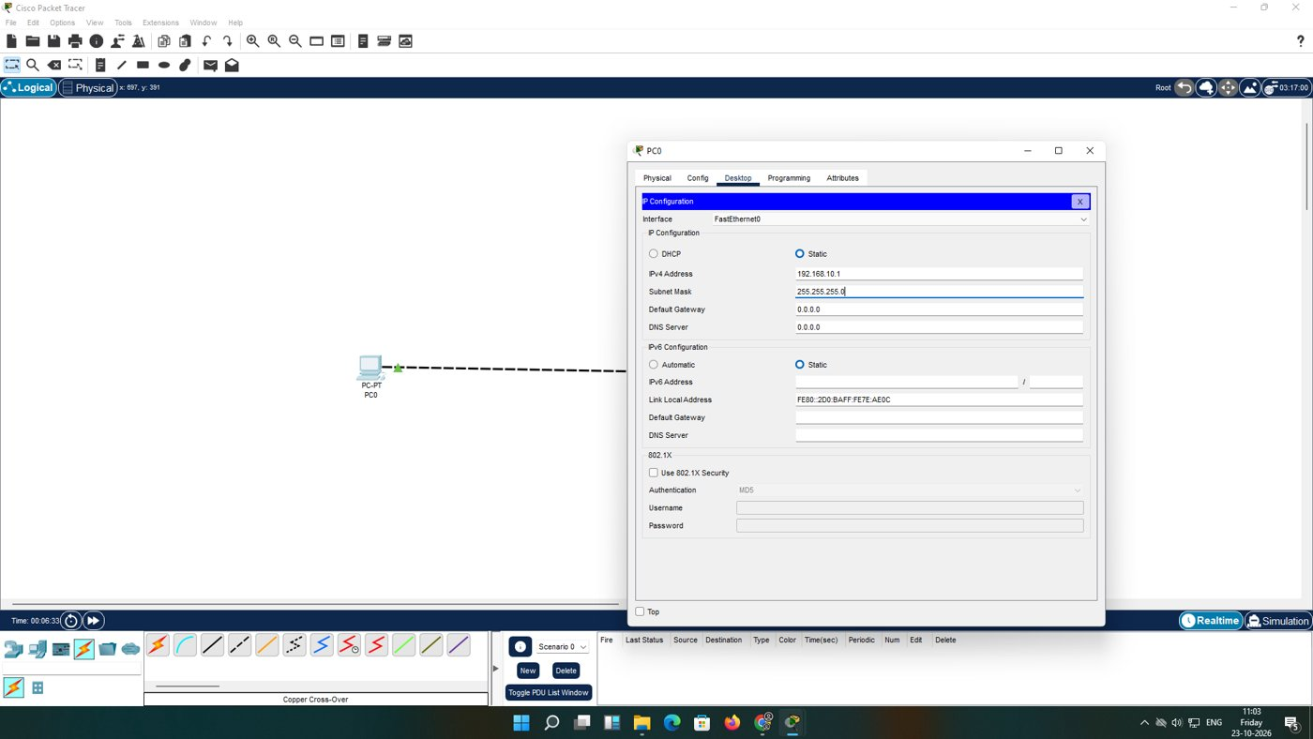
Figure 12: IP Configuration window of PC0
Step 6 - Address PC1. Static address 192.168.10.2, mask 255.255.255.0.
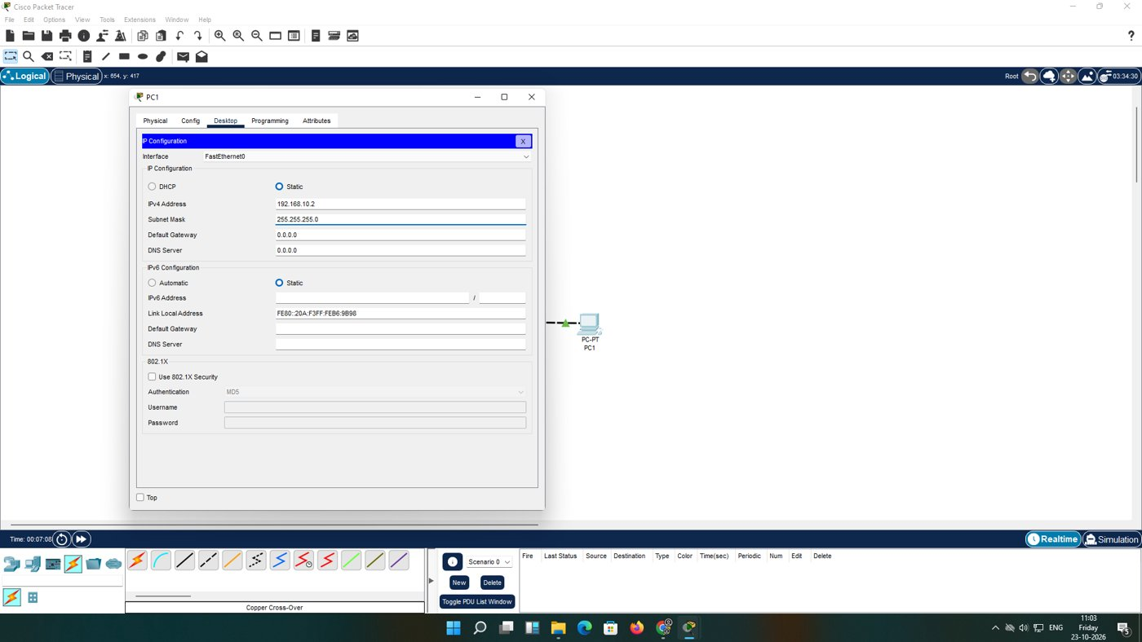
Figure 13: IP Configuration window of PC1
Step 7 - Ping over the cable. On PC0 run ping 192.168.10.2. All four replies arrive in under 1 ms.
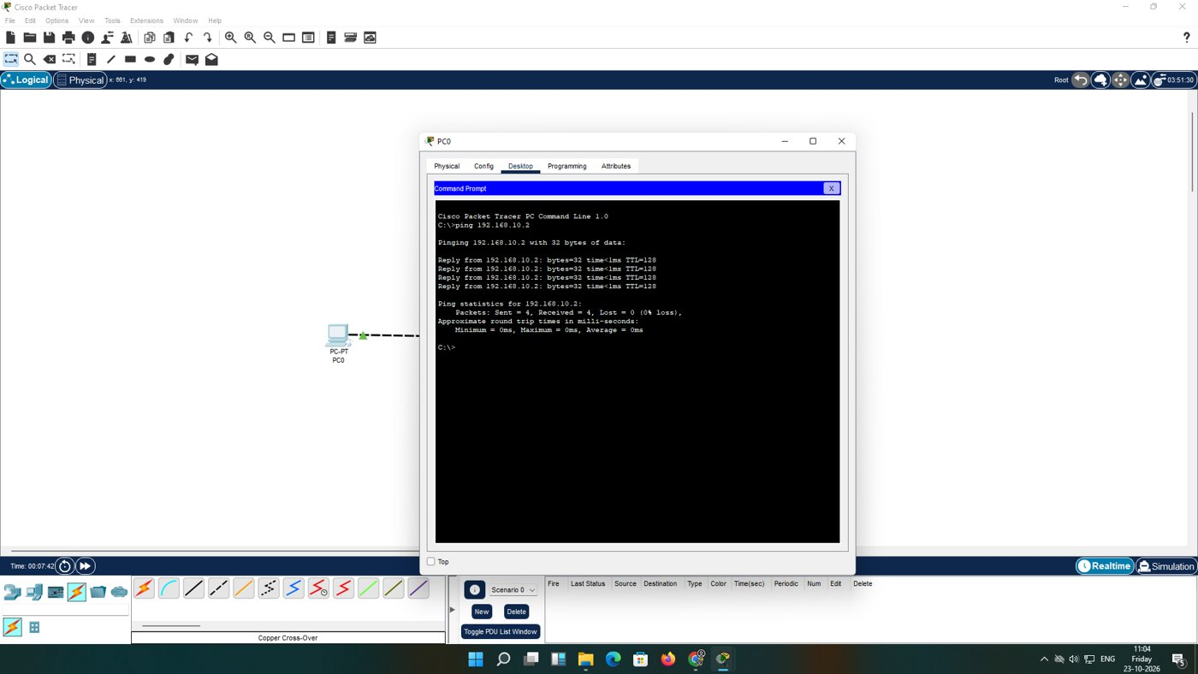
Figure 14: Ping result on PC0
Step 8 - Add a switch. Take a 2960-24TT from the Switches list and drop it in the workspace.
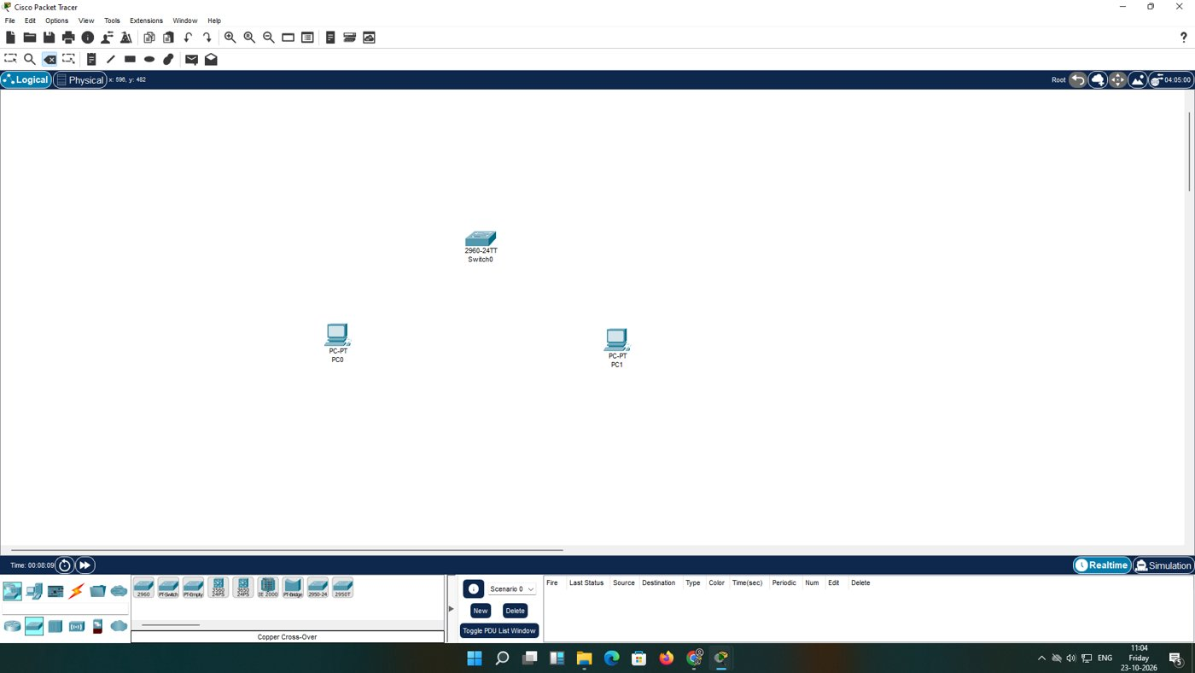
Figure 15: Switch0 added
Step 9 - Re-cable. Delete the cross-over cable, choose Straight-Through and run one cable from each PC to Switch0. Orange dots turn green.
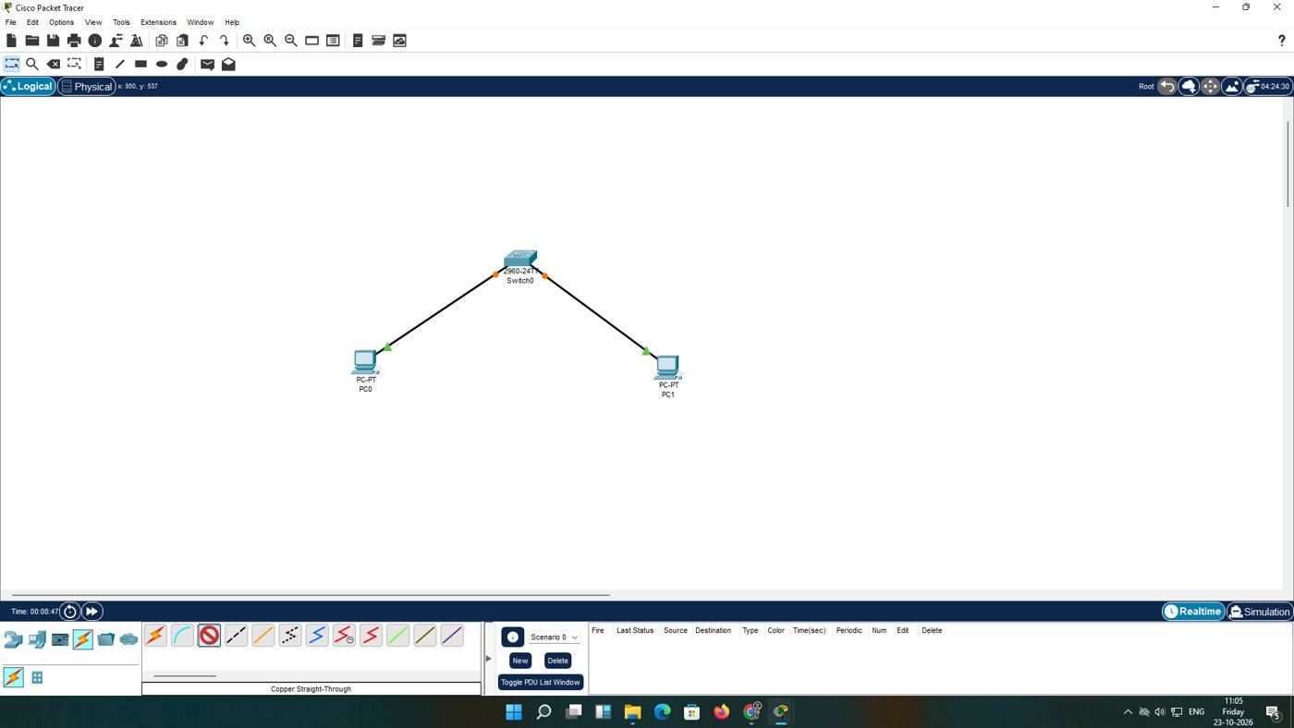
Figure 16: Both PCs connected to Switch0
Step 10 - Ping via the switch. On PC1 run ping 192.168.10.1 and read the replies.
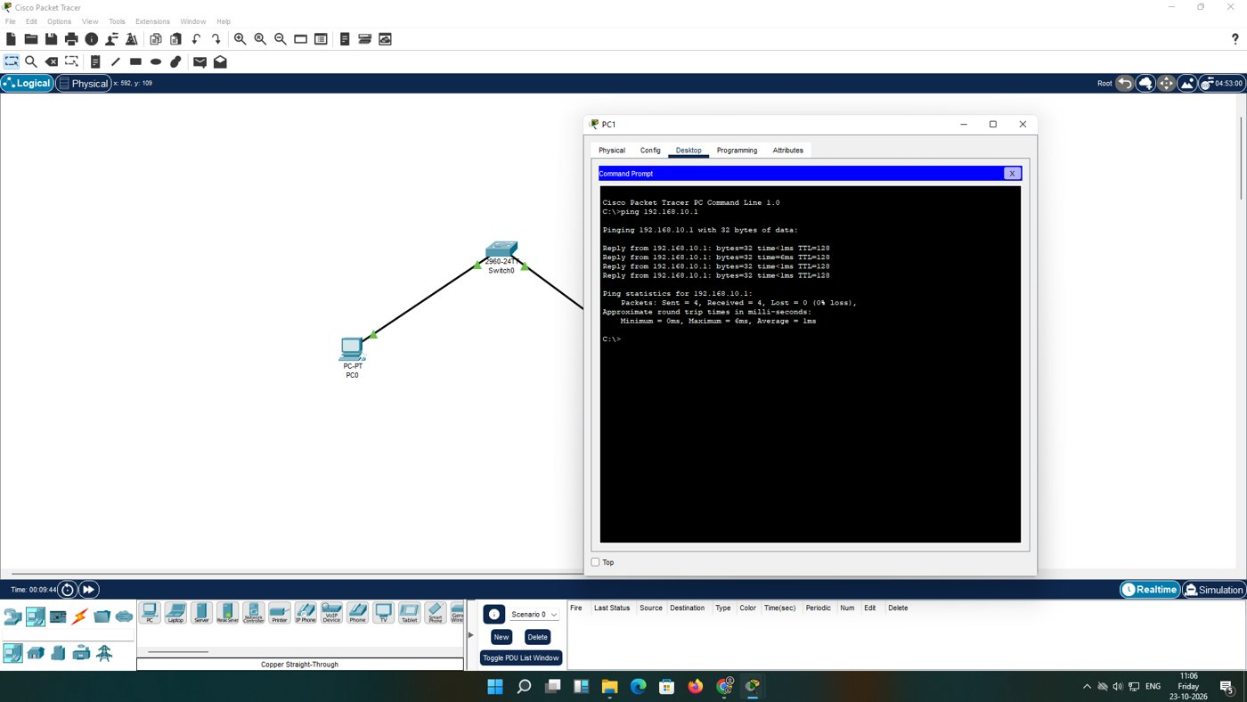
Figure 17: Ping result on PC1 through the switch

5.2 Addressing Table
Device | Interface | IP Address | Subnet Mask | Gateway
PC0 | FastEthernet0 | 192.168.10.1 | 255.255.255.0 | 0.0.0.0
PC1 | FastEthernet0 | 192.168.10.2 | 255.255.255.0 | 0.0.0.0

5.3 Observation
- Cross-over link: 4 of 4 replies, each under 1 ms, TTL 128.
- Through the switch: 4 of 4 replies; minimum 0 ms, maximum 6 ms, average 1 ms. The 6 ms reply is the first one, which waited for ARP and for the switch to learn both MAC addresses.

6. Comparison
Feature | Cross-over (PC-PC) | Switch (straight-through)
Cable | Cross-Over | Straight-Through
Hosts supported | 2 | Many
Link start-up | Immediate | Orange, then green
First-ping delay | None seen | Small, due to ARP

7. Troubleshooting Notes
- A "Request timed out" on the very first ping can be ARP still in progress; run it again.
- Red or dark link ends often mean the wrong cable type.
- No reply with green links usually means a mistyped address or mask.

8. Conclusion
The correct cable plus addresses from one subnet were enough to achieve full connectivity in both set-ups. A switch allows the network to grow, and its only visible cost here was a slightly slower first packet.

